EXPERIMENT NO:5

Q1)

--1.List loan data, ordered by decreasing amounts, then increasing loan numbers:

SELECT * FROM Bank_Loan

ORDER BY loan_amount DESC , loan_number ASC;

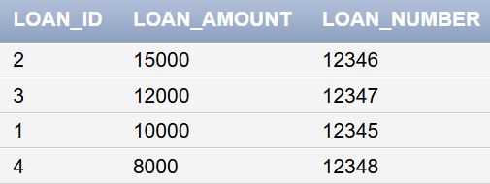

--2.Retrieve a list of all bank branch details, ordered by branch city, with each city’s branches listed in reverse order of holdings:

SELECT * FROM bank_Branch

ORDER BY branch_city ASC , branch_holdings DESC;

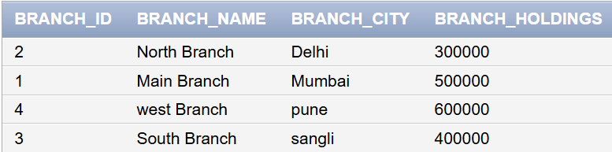

--3.Find the average account balance at each branch:

SELECT branch_id ,AVG(account_balance) as avg_balance

FROM account

GROUP BY branch_id;

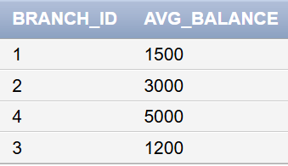

--4.Find the number of customers citywise:

SELECT customer_city , COUNT(*) as num_of_customer

FROM bank_customer

GROUP BY customer_city;

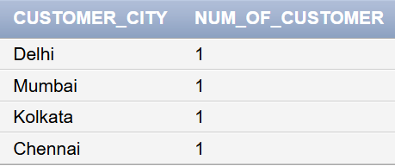

--5.Find the number of branches of the bank:

SELECT COUNT(*) AS num_of_branch

FROM bank_Branch ;

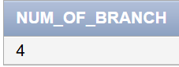

--6.Find the average account balance of those branches where the account balance is greater than Rs. 1200:

SELECT branch_id, AVG(account_balance) AS avg_balance

FROM account

WHERE account_balance > 1200

GROUP BY branch_id;

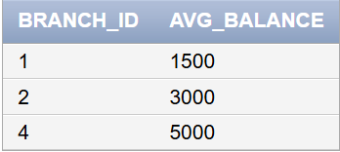

--7.Find all cities with more than two customers living in the city:

SELECT customer_city FROM bank_customer

GROUP BY customer_city

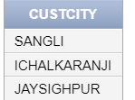HAVING COUNT(*) > 2;

Q2)

-- 1. Display total salary spent for each job category

SELECT Designation,SUM(Salary) as Salary_spent

FROM EMPLOYEE

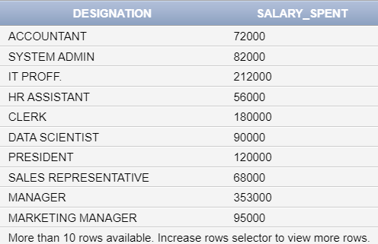GROUP BY Designation;

-- 2. Display lowest paid employee details under each manager

SELECT *

FROM EMPLOYEE

WHERE Salary = (SELECT MIN(Salary) FROM EMPLOYEE);

-- 3. Display number of employees working in each department and their department name

SELECT Dept_name,COUNT(Emp_no) as no_of_employees

FROM EMPLOYEE

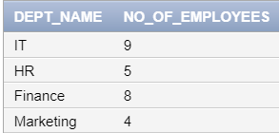GROUP BY Dept_name;

-- 4. Display the details of employees sorting the salary in increasing order

SELECT *

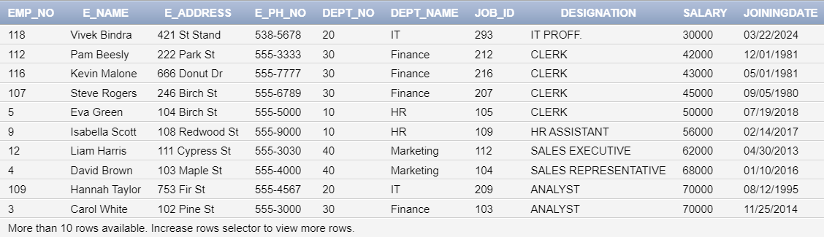FROM EMPLOYEE

ORDER BY Salary ASC;

-- 5. Show the record of employees earning salary greater than 16000 in each department

SELECT *

FROM EMPLOYEE

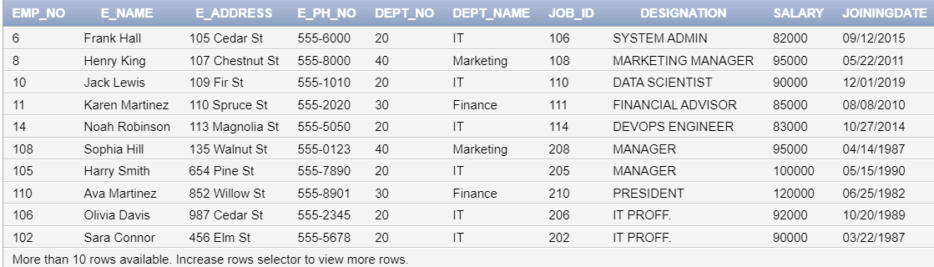WHERE Salary > 80000;